MACH4METAL

Metalworking machinery
Transito 21,
6909 DA BABBERICH
Netherlands
Tel. +31 (0)316 – 247123
Fax. +31 (0)316 - 247956
info@mach4metal.com
www.mach4metal.com

Account No: 66.52.13.883
IBAN : NL33 INGB 0665 2138 83
BIC : INGBNL2A

SKODA W200H - CNC
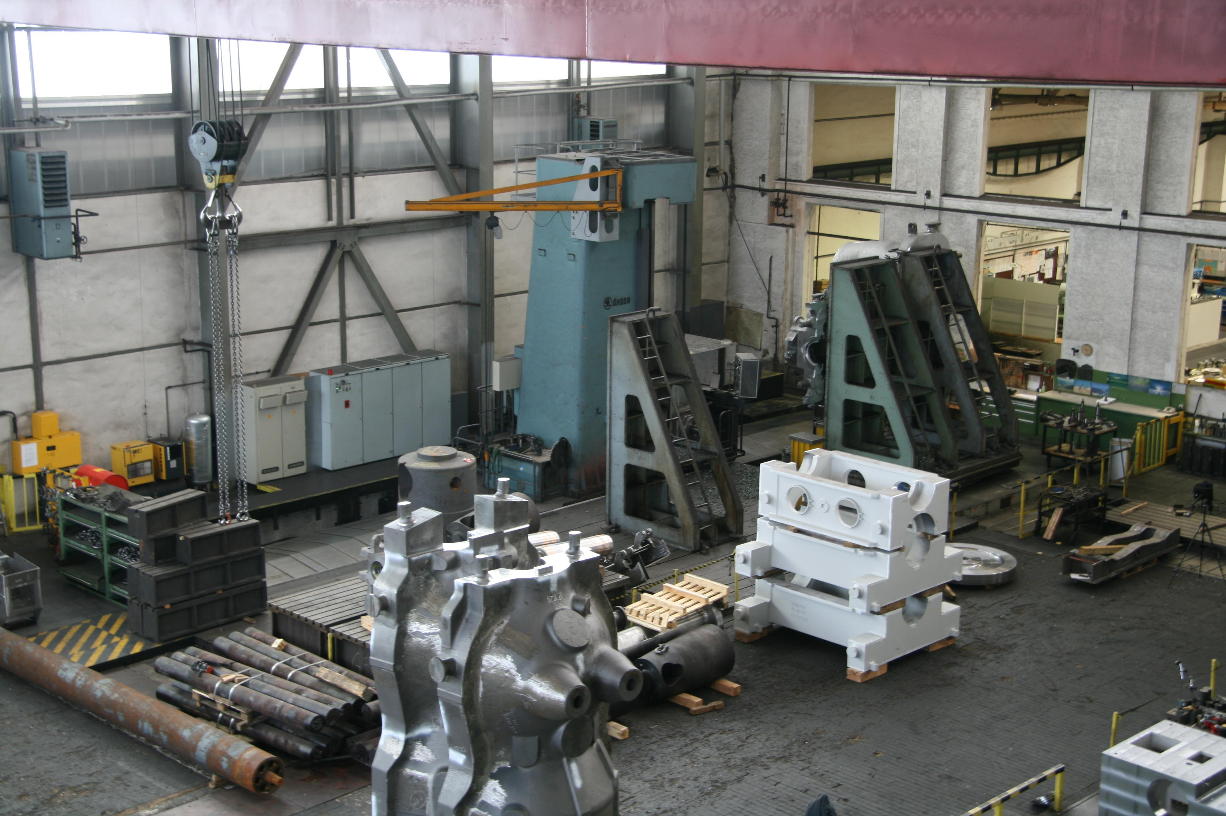

- Make : Skoda - Pilzen
- Typ : W 200 H - CNC
- Mach.No : 3788
- Age : 1981 / 1999

- X – travel : 15.000
- Y – travel : 3.150
- W – travel : 2.000
- Z – travel : 1.600
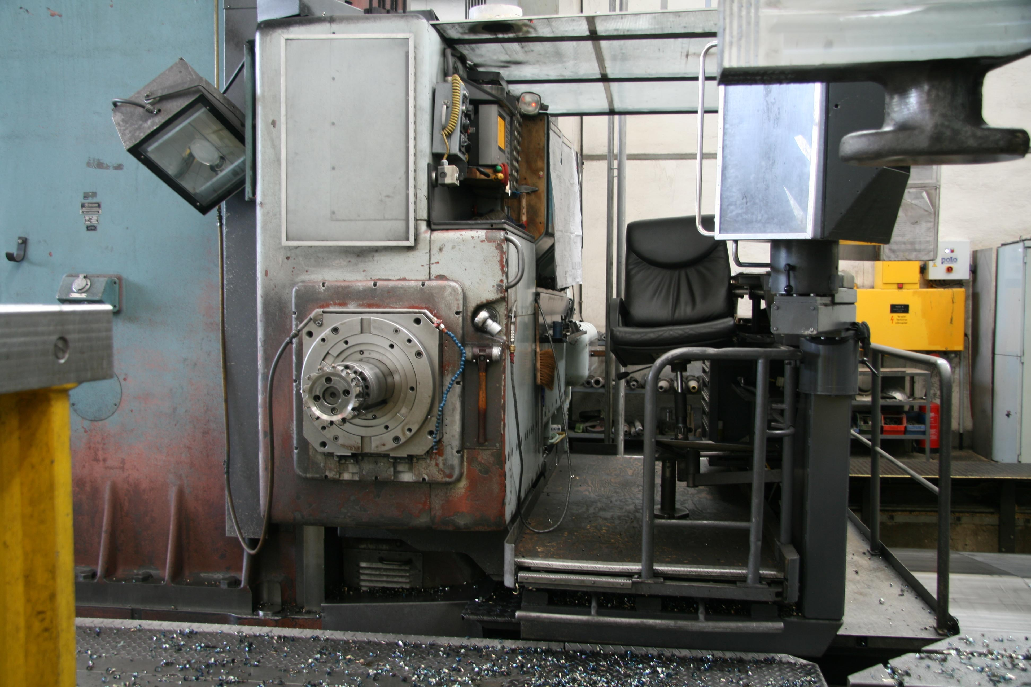
- Spil diam. Ø : 200
- Ram size : 520 x 520
- Power : 77 kW

- Speeds Vario 0,8 – 630 Rpm
- Feed rate 0,63 – 1.250/2.000/3.500

- Floorplate’s: 13.000 x 5.650 mm
- 6 x 6.390 x 1.885 x 350 – T 36

- CNC Control Siemens 810 M
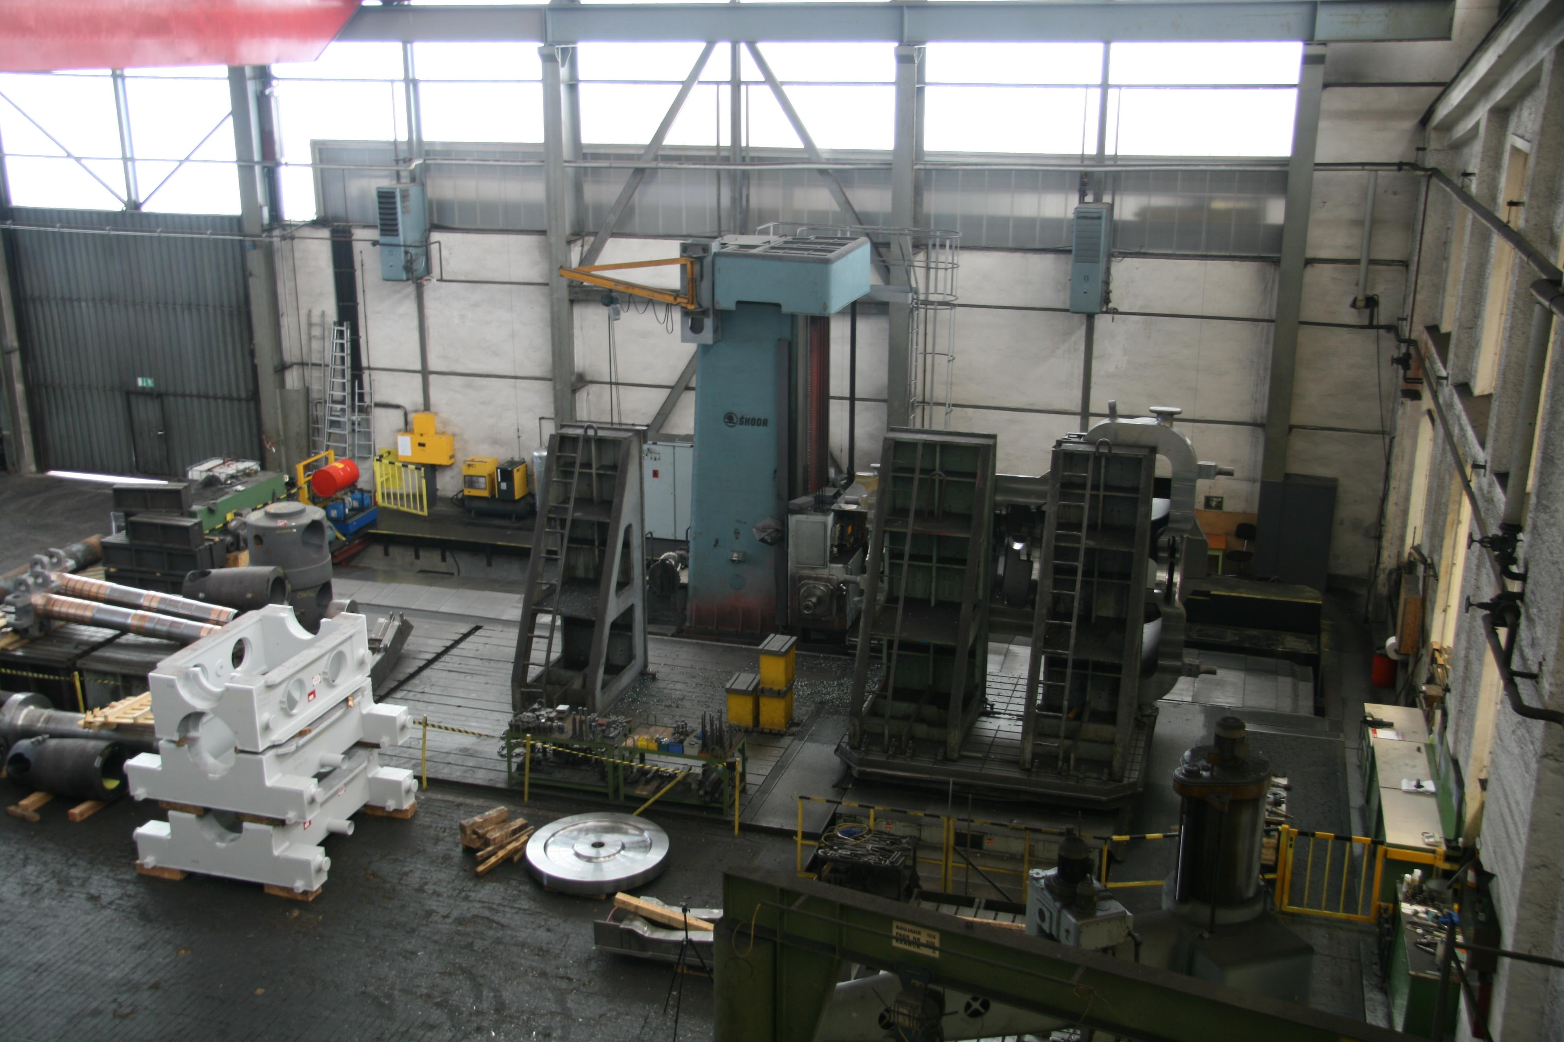
- Skoda rotary table
- Size 4.000 x 3.550 mm
- X – travel 2.100 mm
- Max. load Ca. 80.000 Kg

- Incl. chip conveyor

Please Note: The above information has been obtained to the best of our ability and belief from, and from the manufacturers where possible. It is given in good faith, but its accuracy can not be guaranteed. Accordingly, it will not form a representation or constitute contractual terms. We advise you to check any vital details!

